**VALIDATIONS TESTING**

• All fields in the form must be entered (i.e., all fields are required).(Test cases Passed)

• The check-out date should be greater than the check-in date. (Test cases Passed)

• The last name, first name, city, province/state, and credit card holder’s name should not

contain the following characters: (Test cases Passed)

; : ! @ # $ % ^ * + ? \ / < > 1 2 3 4 5 6 7 8 9 0

• The country should include Canada and US. (Test cases Passed)

• If the selected country is Canada, then the postal code must be a valid Canadian postal code. (Test cases Passed)

• If the selected country is USA, then the postal code must be a valid US zip code. (Test cases Passed)

• If the selected country is US or Canada, the phone number must be a valid US/Canadian

phone number. (Test cases Passed)

• The email address is a valid Internet email address. (Test cases Passed)

• The type of the credit card must be selected. (Test cases Passed)

• The credit card number should consist of digits only, and must have the following properties:

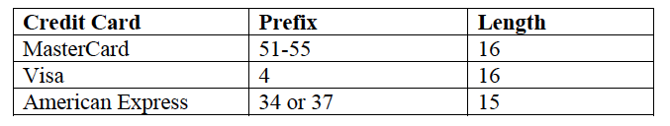

(Test cases Passed)

• The format of the expiration date should be MM/YYYY, where MM means month and

YYYY means year. Both M and Y represent a single digit. The range of MM is between 01

and 12, and YYYY is between 2016 and 2031 (inclusively). (Test cases Passed)